Project Design Phase-II
Technology Stack (Architecture & Stack)

Date | 3rd October 2026
Team ID | SWTID-2026-3114
Project Name | Implement Client Script & UI Policy (Incident)
Maximum Marks | 4 Marks

Technical Architecture:

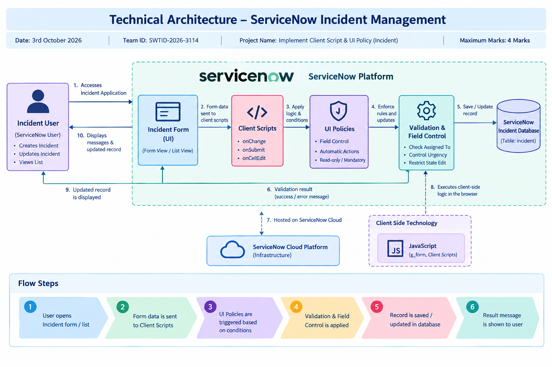

Table-1 : Components & Technologies:

S.No | Component | Description | Technology
- 1 | User Interface | Interface through which users create and update Incident records. | ServiceNow Incident Form & List View
- 2 | Application Logic-1 | Automatically updates Urgency when Impact is changed to High. | JavaScript Client Script – onChange
- 3 | Application Logic-2 | Validates Assigned To before saving a High Impact Incident. | JavaScript Client Script – onSubmit
- 4 | Application Logic-3 | Prevents State changes through direct list editing. | JavaScript Client Script – onCellEdit
- 5 | Database | Stores Incident details such as Impact, Urgency, Assigned To and State. | ServiceNow Incident Database
- 6 | Cloud Database | No separate cloud database is used. Incident data is stored within the ServiceNow platform. | ServiceNow Platform Database
- 7 | File Storage | No separate file storage is required for the implemented solution. | Not Applicable
- 8 | External API-1 | No external API is required for the Incident field controls. | Not Applicable
- 9 | External API-2 | No external API is used in the implementation. | Not Applicable
- 10 | Machine Learning Model | No machine learning model is used in this project. | Not Applicable
- 11 | Infrastructure (Server / Cloud) | The application is configured and executed within the ServiceNow cloud platform. | ServiceNow Cloud Platform

Table-2: Application Characteristics:

S.No | Characteristics | Description | Technology
- 1 | Open-Source Frameworks | No external open-source framework is required. The solution uses native ServiceNow configuration and scripting features. | ServiceNow Platform APIs & JavaScript
- 2 | Security Implementations | Incident access and modification are controlled through ServiceNow user roles and platform access controls. The solution also prevents unintended State changes through list editing. | ServiceNow Roles, Access Controls & Client Scripts
- 3 | Scalable Architecture | The solution uses the ServiceNow platform and applies Client Scripts and UI Policies at the Incident form level, allowing the configuration to be used across Incident records. | ServiceNow Platform
- 4 | Availability | The configuration is hosted within the ServiceNow platform and is available when users access the Incident application. | ServiceNow Cloud Platform
- 5 | Performance | Client-side validation and field control are executed directly on the Incident form, providing immediate response without requiring unnecessary server-side processing. | JavaScript, g_form, Client Scripts & UI Policies

